TB10A（TB1025） micro computer timer switch
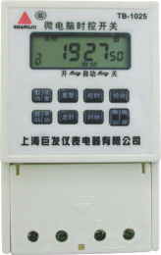
- Function:

The product adopts PJ-62 timer module, which can turn on or turn off power supply of all kinds of electric equipments automatically according to user’s time. It is widely used for the programmable automatically time control of road lamp, neon lamp, billboard, electric cooker, oxygen-added machine, spray machine, pre-hot and pre-cool device and any equipments with electric need time control.

- LCD code instruction

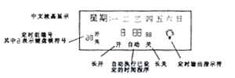

- Technical index:

Rated voltage: 220V/50Hz
Applicable voltage range: 160~240V
Rated Current: Pure resistant load 30A、Sensibility load 20A
Timer range: 1min~168Hrs
Setting times: 10 groups or 20 groups programmable everyday
(e.g. 9:00 ON and 10:00 OFF as a group programmable)
Control period: cycle by day or by week (can set different time every day in a week)
Time error: <±0.5s/day
Working temperature: -30℃～60℃ water-proof and dust proof
Mounting size: 115×75×52mm
Connecting method: connect by lock type terminal, subject to industrial standard.

- Key board lock, clock adjustment, time setting

Pressing the key “CANCEL/RETURN” for 3 seconds continually can open or cancel the code of the key board lock. Pressing the key “ HOUR” can adjust the hour clock, pressing the keys of “HOUR”,”MINUTE”,”WEEK” at the same time can adjust the clock and week.
Time setting steps as below:

Steps | Keys | Program setting
1 | Press key “Time” | The first group time setting ON (show1)
2 | Press the keys “week”, “Hour”, “ Minute”separately | To set open time (week, hour, minute)
3 | Press key “Time” again | The first group time setting OFF ( show 1)
4 | Press the keys “week”, “Hour”, “Minute”separately | To set close time (week, hour, minute)
5 | Repeat the steps 1,2,3,4 | Can set 2-10 groups ON/OFF
6 | Press key “Time” continually | Check, if not agree with requirements, please repeat steps 2 and 4
7 | Press key “Auto/Manual” | Accord the switch with“ ▼ ” and adjust to the present situation (ON or OFF), and adjust back to the “Auto” position.
8 | Press key “clock” | End the time setting and enter the clock display situation
Note: If you don’t need set 10 groups, you can cancel the unwanted groups with key “CANCEL/RETURN”, show “--:--” means cancel, if press “CANCEL/RETURN” again, and then return the former time.
Check: Press the key “ Time” to check every group time or week to be correct or not.
Manual control: Pressing the key “CANCEL/RETURN” can open or close power source directly, ON means open situation and OFF means close situation, Action means time program has been done.
At non-clock display situation, please press the key” Clock “ and don’t press any key for 30 seconds, conserving the present setting can return to the clock LCD situation.
If need setting day cycle, please make sure that the ON/OFF time shall be set with WEEK displaying. See the picture:
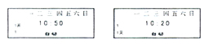
V. Wiring connection

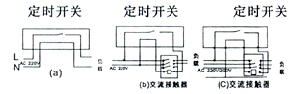
Product executive standard: GB14048.3-93
- Notices

If the LCD is weak, please change the battery; if the contents disappear, then need reset.
Don’t repair, discharge or alteration the product by yourself.
Don’t taint with oil or water.
The product only needs one battery of 1.5V for power supplying. (The battery is installed front, easy to change), and the other space for battery is spare for change battery, thus can prevent electric leakage and program lost.

